**1.Mobile number validation:**

%{

%}

%%

[6-9][0-9]{9} {printf("\nMobile Number valid\n");}

.+ {printf("\nMobile Number Invalid\n");}

%%

int yywrap(void) {}

int main()

{

printf("\nEnter Mobile Number:");

yylex();

printf("\n");

return 0;

}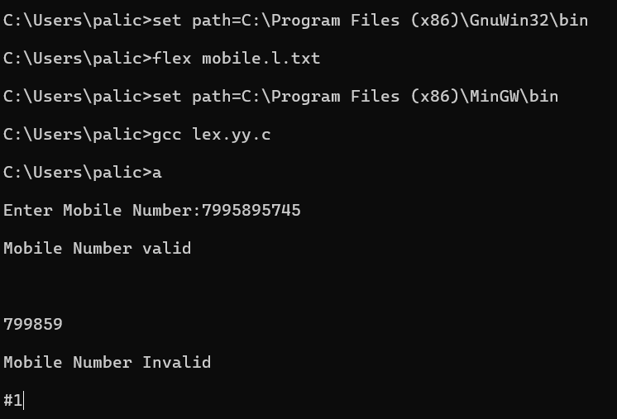

2.digit:

%{

%}

%%

[0-9]+|[0-9]*\.[0-9]+ {printf("\ngiven is a digit\n");}

.+ {printf("\ngiven is not a digit\n");}

%%

int yywrap(void) {}

int main()

{

printf("\nEnter a digit:");

yylex();

printf("\n");

return 0;

}

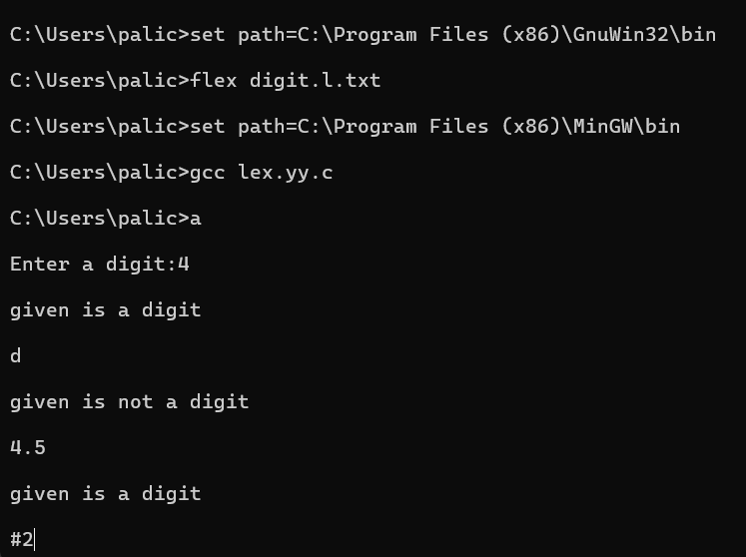

3.identifier:

%{

%}

%%

[a-zA-Z][a-zA-Z0-9]* {printf("\ngiven is a identifier\n");}

.+ {printf("\ngiven is not a identifier\n");}

%%

int yywrap(void) {}

int main()

{

printf("\nEnter a identifier:");

yylex();

printf("\n");

return 0;

}

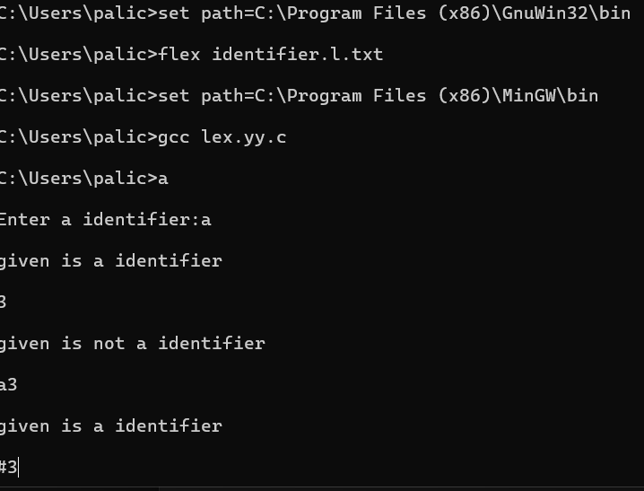

4,vowels and consonents:

%{

int vow_count=0;

int const_count=0;

%}

%%

[aeiouAEIOU] {vow_count++;}

[a-zA-Z] {const_count++;}

%%

int yywrap(void) {}

int main()

{

printf("\nEnter a string of vowels and consonents:");

yylex();

printf("enter no.of vowels::%d\n",vow_count);

printf("enter no.of consonents::%d\n",const_count);

return 0;

}

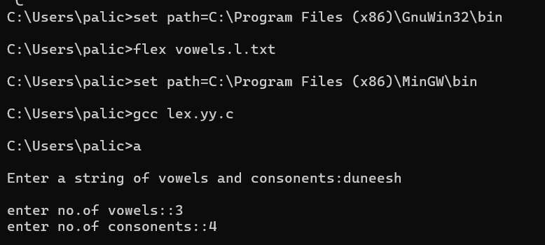

5.email is valid or not:

%{

%}

%%

[a-z.0-9_]+@[a-z]+".com"|".in" {printf("\nemail is valid\n");}

.+ {printf("\nemail is not valid\n");}

%%

int yywrap(void) {}

int main()

{

printf("\nEnter a email:");

yylex();

printf("\n");

return 0;

}

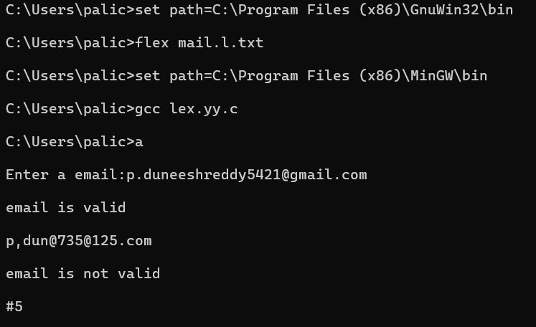

6.keyword and identifier:

%{

%}

%%

if|else|while|for|return|main|int|char|switch|float|break {printf("\ngiven is a keyword\n");}

[a-zA-Z][a-zA-Z0-9]* {printf("\ngiven is a identifier\n");}

.+ {printf("\ngiven is not a identifier and not a keyword\n");}

%%

int yywrap(void) {}

int main()

{

printf("\nEnter the string:");

yylex();

printf("\n");

return 0;

}

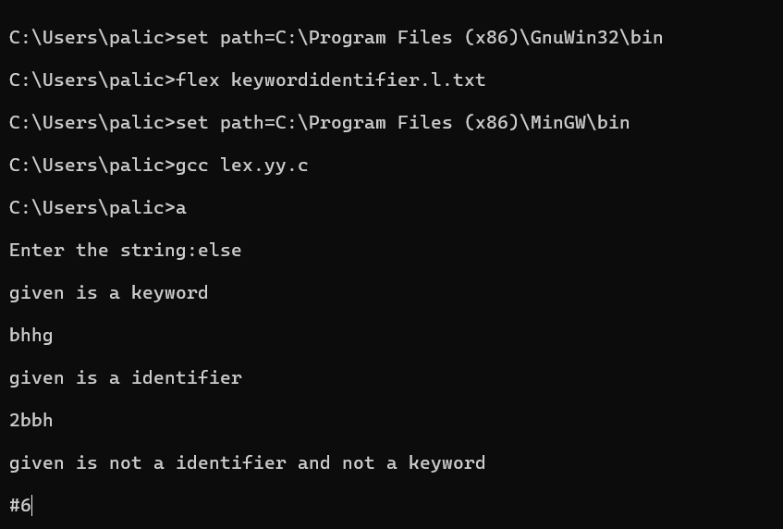

7.capitals:

%{

%}

%%

[A-Z]+ {printf("\ngiven string is capitals\n");}

.+ {printf("\ngiven string not all letters are capitals\n");}

%%

int yywrap(void) {}

int main()

{

printf("\nEnter a string:");

yylex();

printf("\n");

return 0;

}

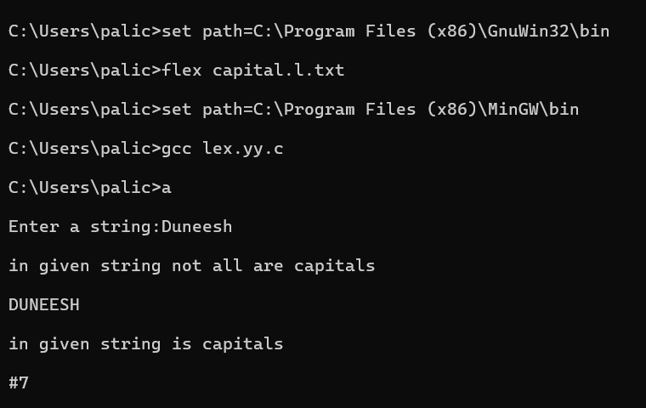

8.add line numbers:

Input:

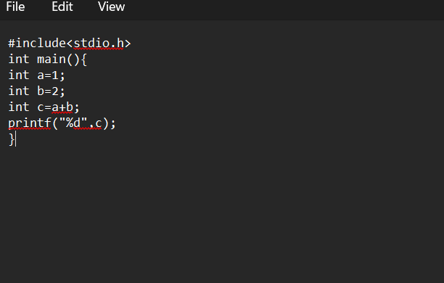

Output:

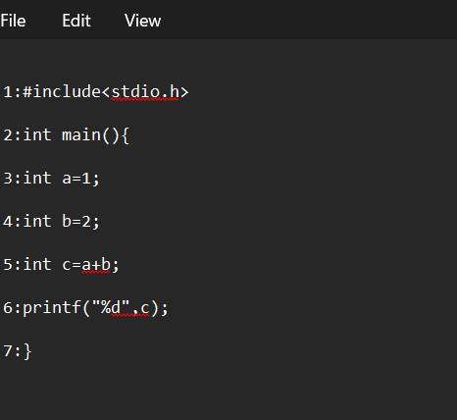

9.longest word:

%{

int counter=0;

%}

%%

[a-zA-Z]+ {

if(yyleng>counter) {

counter=yyleng;

}

}

%%

int yywrap(){}

int main()

{

printf("enter the sentence: ");

yylex();

printf("longest word is:%d",counter);

printf("\n");

}

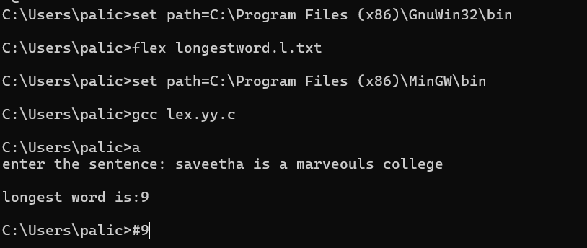

10.valid url:

%{

%}

%%

[http://]+[www.]+[a-z]+".com" {printf("\n valid url\n");}

.+ {printf("\n in valid url\n");}

%%

int yywrap(){}

int main()

{

printf("\n enter the url:");

yylex();

}

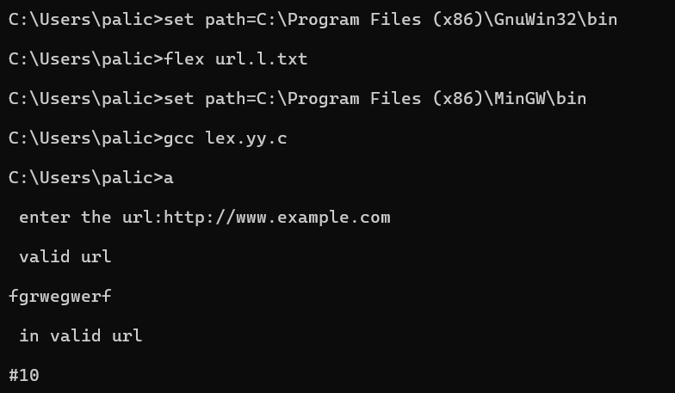

11.date of birth:

%{

%}

%%

[0-9][0-9]\/[0-1][0-9]\/[1-2][0-9]{3} {printf("valid date of birt");}

.+ {printf("invalid date of birt");}

%%

int yywrap(){}

int main()

{

printf("enter the date of birth: ");

yylex();

printf("\n");

}

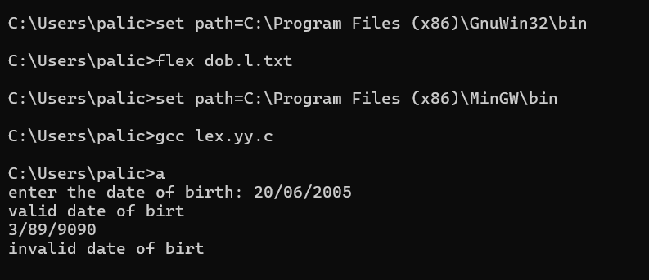

12:relational operators:

%{

%}

%%

[a-z]+ {printf("word: %s\n",yytext);}

">"|"<"|"<="|">="|"=="|"!=" {printf("relational operator: %s\n",yytext);}

%%

int yywrap(){}

int main()

{

printf("enter the combination of words and relops: ");

yylex();

printf("\n");

}

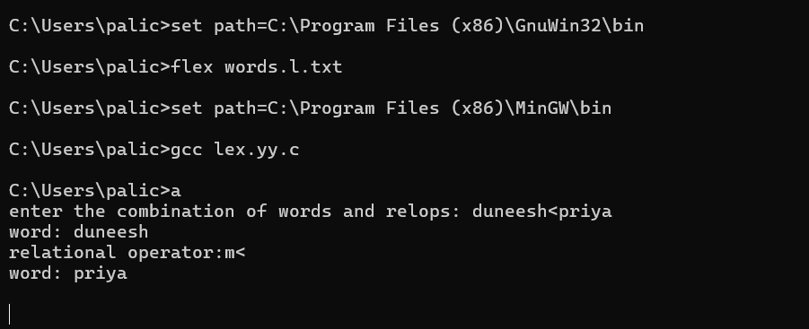

13.no of charecters:

%{

#include <stdio.h>

int i=0, l=0, c=0;

%}

%%

\n { i++; }

[a-zA-Z0-9]+ { l++; c += yyleng; }

. { c++; }

%%

int yywrap() {}

int main() {

printf("enter the string: ");

yylex();

printf("no of lines: %d\n", i);

printf("no of words: %d\n", l);

printf("no of characters: %d\n", c);

}

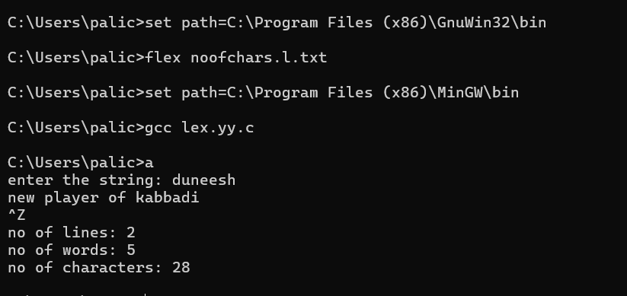

14.comment lines:

%{

#include<stdio.h>

int n=0;

%}

%%

"/"[a-zA-Z0-9 \n\t]+"/" {n++;}

"//"[a-zA-Z0-9 \n\t]+"//" {n++;}

%%

int yywrap()

{}

int main()

{

printf("enter the input:");

yylex();

printf("count no of comment lines:%d",n);

}

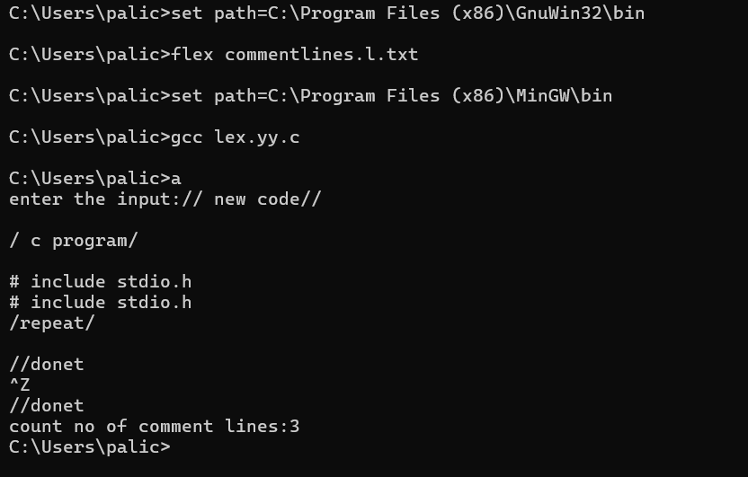

15.html:

Input:

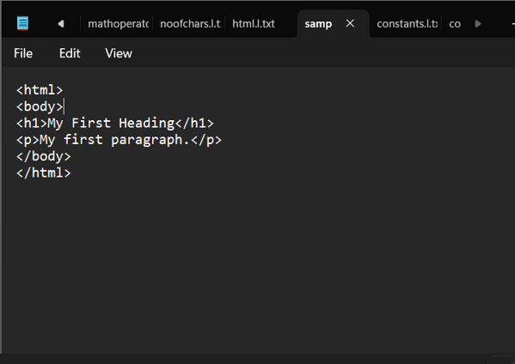

Output:

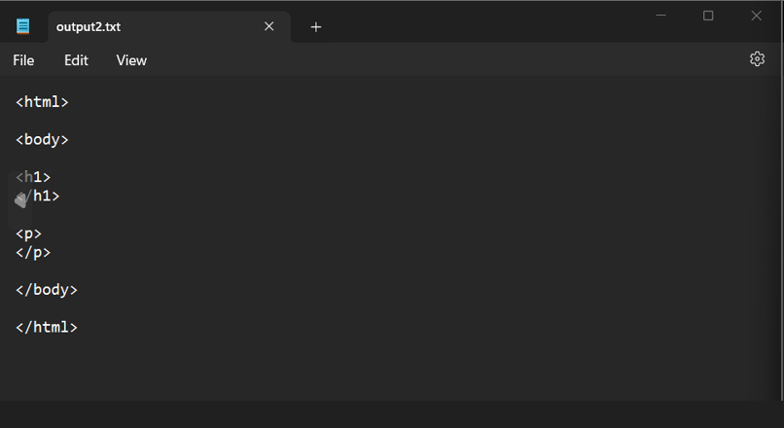

16.constants:

%{

int cons = 0;

%}

digit [0-9]

%%

{digit}+"."{digit}+ { cons++; printf("%s is a floating-point constant\n", yytext); }

{digit}+ { cons++; printf("%s is an integer constant\n", yytext); }

.|\n { }

%%

int yywrap() {

}

int main() {

printf("Enter the code:");

yylex();

printf("Number of Constants: %d\n", cons);

return 0;

}

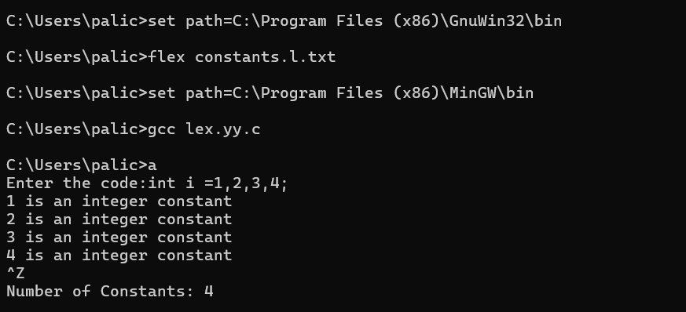

17.positive or negative numbers:

%{

int positive_no=0,negative_no=0;

%}

%%

[-][0-9]+ {negative_no++;

printf("negative number=%s\n",yytext);}

[0-9]+ {positive_no++;

printf("positive number=%s\n",yytext);}

%%

int yywrap(){}

int main()

{

yylex();

printf("number of posive integers=%d,"

"number of negativenumbers=%d\n",

positive_no,negative_no);

return 0;

}

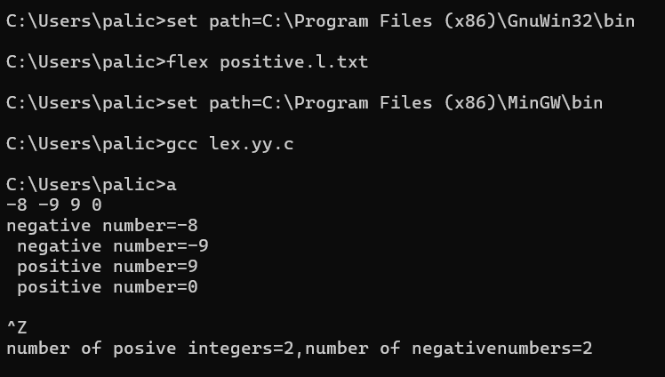

18.substring:

%{

#include <ctype.h>

%}

%%

[a-z] { printf("%c", toupper(yytext[0])); }

.|\n { printf("%s", yytext); }

%%

int yywrap()

{

}

int main() {

yylex();

return 0;

}

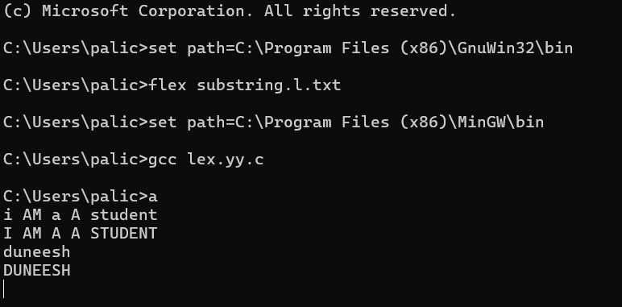

19.macros:

%{

int nmacro = 0, nheader = 0; // Initialize counters

%}

%%

"#define" { nmacro++; } // Increment macro counter for "#define"

"#include" { nheader++; } // Increment header counter for "#include"

.|\n { } // Ignore all other characters

%%

int yywrap() {

return 1;

}

int main() {

printf("Enter the string:\n");

yylex(); // Start lexical analysi

// Corrected printf statement

printf("Number of macros defined = %d\n", nmacro);

printf("Number of header files included = %d\n", nheader);

return 0;

}

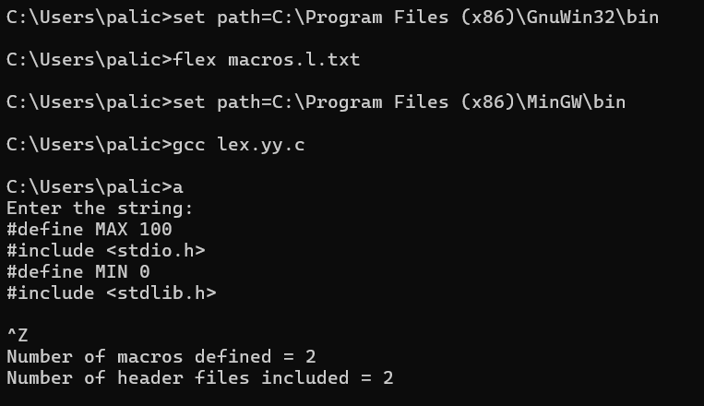

20.frequency:

%{

#include<stdio.h>

#include<string.h>

char word [] = "geeks";

int count = 0;

%}

%%

[a-zA-Z]+ { if(strcmp(yytext, word)==0) count++; }

. ;

%%

int yywrap()

{

return 1;

}

int main()

{

extern FILE *yyin, *yyout;

yyin=fopen("input.txt", "r");

yylex();

printf("%d", count);

}

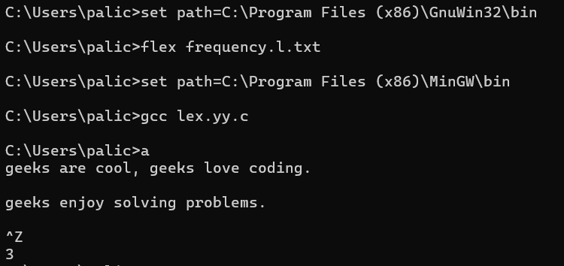

21.math operators:

%{

float op1, op2;

%}

%%

"+" { printf("sum = %f\n", op1 + op2); }

"-" { printf("diff = %f\n", op1 - op2); }

"*" { printf("mul = %f\n", op1 * op2); }

"/" {

if (op2 != 0)

printf("div = %f\n", op1 / op2);

else

printf("Error: Division by zero is not allowed.\n");

}

. { printf("Invalid operator. Please enter a valid operator.\n"); }

%%

int yywrap() {}

int main() {

printf("Enter number 1: ");

scanf("%f", &op1);

printf("Enter number 2: ");

scanf("%f", &op2);

printf("Enter the Operator (+, -, *, /): ");

yylex();

return 0;

}

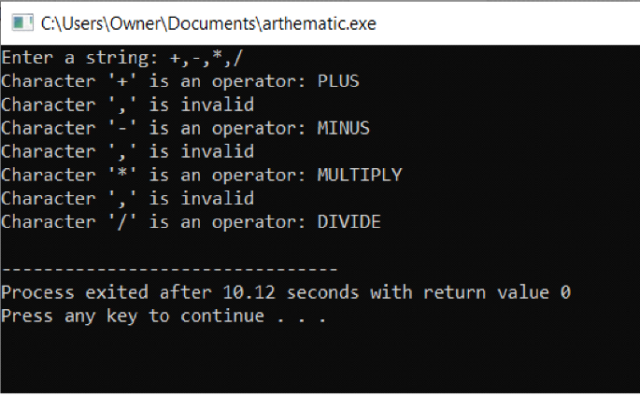

22.replace:

%{

#include<stdio.h>

#include<string.h>

char replace_with [100];

char replace [100];

%}

%%

[a-zA-Z]+ { if(strcmp(yytext, replace)==0)

fprintf(yyout, "%s", replace_with);

else

fprintf(yyout, "%s", yytext);}

. fprintf(yyout, "%s", yytext);

%%

int yywrap()

{

return 1;

}

int main()

{

printf("enter replacing string:\n");

scanf("%s",&replace);

printf("\nenter replacing with string:\n");

scanf("%s",&replace_with);

printf("enter a input string:\n");

yylex();

}